Исламов Радмир ПИН-23

Упражнение 1

clear

clc

subplot(2,1,1)

hold on

grid on

syms n

s = solve('(3*n^4 + 6*n) / (n^4 - 7*n^3 + 1) - 3 = 0.01', n);

n0 = 2107;

a = limit((3*n^4 + 6*n) / (n^4 - 7*n^3 + 1),Inf);

e = 0.01;

n = n0-5:1:n0+10;

xn = (3*n.^4 + 6*n) ./ (n.^4 - 7*n.^3 + 1);

plot(n,xn, 'r.')

line([n0-5 n0+10], [a+e a+e],'color','blue')

line([n0-5 n0+10], [a-e a-e],'color','blue')

clear n

n = n0;

abs((3*n^4 + 6*n)/(n^4 - 7*n^3 + 1) - 3) - e

n = n + 1;

abs((3*n^4 + 6*n)/(n^4 - 7*n^3 + 1) - 3) - e

subplot(2,1,2)

hold on

grid on

syms n

s = solve('(3*n^4 + 6*n) / (n^4 - 7*n^3 + 1) - 3 = 0.001', n);

n0 = 21007;

a = limit((3*n^4 + 6*n) / (n^4 - 7*n^3 + 1),Inf);

e = 0.001;

n = n0-5:1:n0+10;

xn = (3*n.^4 + 6*n) ./ (n.^4 - 7*n.^3 + 1);

plot(n,xn, 'r.')

line([n0-5 n0+10], [a+e a+e],'color','blue')

line([n0-5 n0+10], [a-e a-e],'color','blue')

clear n

n = n0;

abs((3*n^4 + 6*n)/(n^4 - 7*n^3 + 1) - 3) - e

n = n + 1;

abs((3*n^4 + 6*n)/(n^4 - 7*n^3 + 1) - 3) - e

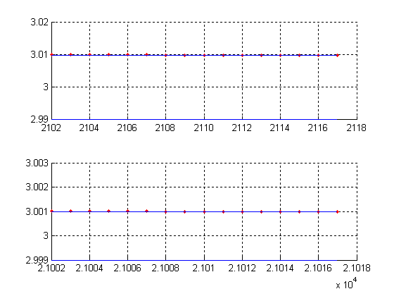

**Проверка:**

**ans = 6.4343e-010**

**ans = -4.7590e-006**

**ans = 6.4737e-013**

**ans = -4.7616e-008**

Сравнение полученных значений:

|  |  |  |
| --- | --- | --- |
|  | e = 0.01 | e = 0.001 |
| n0 мое | 5400 | 54000 |
| n0 matlab | 2107 | 21007 |

Упражнение 2

x0 = 2;

syms x

a = limit((x^2-2*x) / (x^3 + x - 10), 2);

subplot(2,1,1)

hold on

grid on

e = 0.01;

s1 = solve('(x^2-2*x) / (x^3 + x - 10) - (2/13) = 0.01');

s2 = solve('(x^2-2*x) / (x^3 + x - 10) - (2/13) = -0.01');

d1 = abs(s1-x0);

d2 = abs(s2-x0);

d = 0.58720020602956459698999061215902; %выбрали меньшее

x = x0-1:0.01:x0+1;

y = (x.^2-2*x) ./ (x.^3 + x - 10);

plot(x,y,'r','linewidth' , 2);

line([x0-1 x0+1], [a+e a+e], 'color', 'blue', 'linewidth' , 2)

line([x0-1 x0+1], [a-e a-e], 'color', 'blue', 'linewidth' , 2)

line([x0-d x0-d], [a-e a+e], 'color', 'blue', 'linewidth' , 2)

line([x0+d x0+d], [a-e a+e], 'color', 'blue', 'linewidth' , 2)

plot(x0, a, 'go','linewidth' , 2)

subplot(2,1,2)

hold on

grid on

e = 0.001;

s1 = solve('(x^2-2*x) / (x^3 + x - 10) - (2/13) = 0.001');

s2 = solve('(x^2-2*x) / (x^3 + x - 10) - (2/13) = -0.001');

d1 = abs(s1-x0);

d2 = abs(s2-x0);

d = 0.12702885916651444910994487333849; %выбрали меньшее

x = x0-0.5:0.01:x0+0.5;

y = (x.^2-2*x) ./ (x.^3 + x - 10);

plot(x,y,'r','linewidth' , 2);

line([x0-0.5 x0+0.5], [a+e a+e], 'color', 'blue', 'linewidth' , 2)

line([x0-0.5 x0+0.5], [a-e a-e], 'color', 'blue', 'linewidth' , 2)

line([x0-d x0-d], [a-e a+e], 'color', 'blue', 'linewidth' , 2)

line([x0+d x0+d], [a-e a+e], 'color', 'blue', 'linewidth' , 2)

plot(x0, a, 'go','linewidth' , 2)

axis([1.5 2.5 0.152 0.156])

|  |  |  |
| --- | --- | --- |
|  | **e = 0.01** | **e = 0.001** |
| **δ мое** | 0.21667 | 0.0216 |
| **δ Matlab** | 0.5872 | 0.1270 |

Аналитическая формула:

**δ = $\min\left\{\frac{65ε}{3}, 2\right\}$**

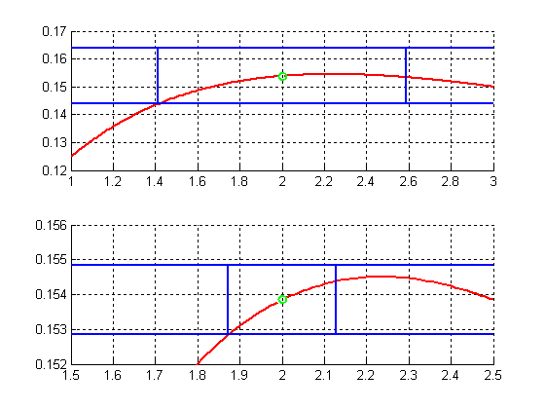

Упражнение 3

x = -0.3:0.025:0.3;

y = (x.^2) ./ ((1 + 3.*x).^(1/3) - (1+x));

plot(x,y);

syms x

hold on

grid on

line([-0.3 0], [-1 -1], 'color', 'black', 'linewidth', 2)

line([0 0],[-1 -5],'color', 'black', 'linewidth', 2)

a = limit((x.^2)./ ((1 + 3.*x).^(1/3) - (1+x)), 0); %-1

plot(0,a,'or');



Упражнение 4

hold on

grid on

syms x

a = limit((cos(5*x) - cos(x) * cos(2*x)) / (1 - cos(2*x)), 0); %-5

x = -3:0.05:3;

y = (cos(5.*x) - cos(x) .* cos(2.*x)) ./ (1 - cos(2.*x));

plot(x,y)

plot(0, a, 'ro')

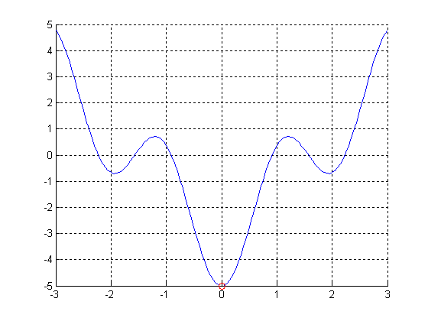

Упражнение 5

hold on

grid on

syms x

a = limit(((4^x + 1) / (4^x + 3))^(-4^x),+Inf); %e^2

x = 5:0.05:8;

y = ((4.^x + 1) ./ (4.^x + 3)).^(-4.^x);

plot(x,y);

line([5 8],[exp(2) exp(2)],'color','red','linewidth',2)



Упражнение 6

hold on

grid on

p = 2;

x0 = 0;

x = -1:0.1:1;

y = 3 .^ (1 - cos(5.*x)) - 1;

plot(x,y)

syms x

C = limit((3 ^ (1 - cos(5*x)) - 1) / (x - x0)^p, x0);

x = -1:0.1:1;

y = C .*(x-x0).^p;

plot(x,y,'r-') 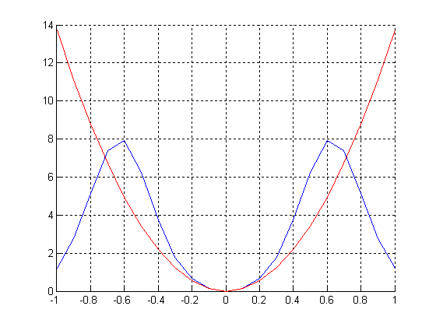

Упражнение 7

hold on

grid on

x0 = 1;

p = 1;

syms x

C = limit((x^(2/3) - 2*sqrt(x) + 1) / (x-x0)^p, x0)

x = x0-1:0.01:x0+1;

y = x.^(2/3) - 2*sqrt(x) + 1;

plot(x,y)

y = C .* (x-x0).^p;

plot(x,y,'r-')

plot(x0, 0,'go','linewidth',2)



Упражнение 8

subplot(2,1,1)

hold on

grid on

x = -0.99:0.025:1;

y = 2 * (2.^x - 1);

plot(x,y);

y = 2.*x*log(2);

plot(x,y,'r')

line([-1 0], [0 0], 'color', 'black')

line([0 0], [-4 0], 'color', 'black')

subplot(2,1,2)

hold on

grid on

x = -0.99:0.025:1;

y = log(x+1);

plot(x,y)

y = x;

plot(x,y,'r')

line([-1 0], [0 0], 'color', 'black')

line([0 0], [-4 0], 'color', 'black')



Упражнение 9

x = -2:0.25:2;

subplot(2,1,1)

hold on

grid on

y = sqrt(1 + sin(2.*x)) - sqrt(1 - sin(2.*x));

plot(x,y)

y = 2 * x;

plot(x,y,'ro')

line([-2 0], [0 0], 'color', 'black')

line([0 0], [-4 0], 'color', 'black')

subplot(2,1,2)

hold on

grid on

x = -1:0.25:1;

y = tan(x);

plot(x,y)

y = x;

plot(x,y,'ro')

line([-1 0], [0 0], 'color', 'black')

line([0 0], [-4 0], 'color', 'black')

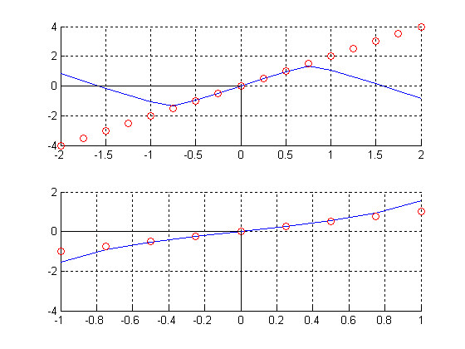

Упражнение 10

x = -1:0.02:1;

y = x .* sin(1./x);

hold on

grid on

axis equal

plot(x,y);

syms x

a = limit(x * sin(1/x), 0); %0

plot(0, a, 'ro');

